**Design & Technology**

**

**Polymer finishing**

**Materials required for questions**

* Pencil
* Rubber
* Calculator

**Instructions**

* Use black ink or ball-point pen
* Try answer all questions
* Use the space provided to answer questions
* Calculators can be used if necessary
* For the multiple choice questions, circle your answer

**Advice**

* Marks for each question are in brackets
* Read each question fully
* Try to answer every question
* Don’t spend too much time on one question

**Good luck!**

**Q1.** What is a 'self-finishing' polymer?

**A** A polymer that requires additional coatings for protection

**B** A polymer that has an acceptable surface finish straight from production

**C** A polymer that can only be painted

**Q2.** Acrylic spray paints are commonly used on polymers because they:

**A** Chemically bond with the polymer surface

**B** Provide a durable, fast-drying finish

**C** Only work on thermosetting plastics

**Q3.** Thermoplastic elastomers (TPE) are often used in products like grips and seals because they:

**A** Are rigid and brittle

**B** Combine flexibility with durability

**C** Cannot be coloured during moulding

**Q4.** What is the purpose of adding pigments to polymers during moulding?

**A** To increase melting temperature

**B** To reduce production costs

**C** To provide colour without post-processing

**Q5.** Give three reasons why a gel coat is used when laminating a glass reinforced plastic (GRP) product **(3 marks)**

**Q6.** Explain why thermoplastic elastomer (TPE) is a suitable material for the manufacture of the grips in this grip strength training tool **(4 marks)**

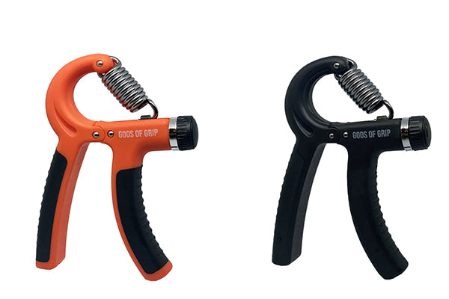

**Answers**

**Q1**. B

**Q2**. B

**Q3**. B

**Q4**. C

**Q5.**

Gel coat:

* can be used to provide a pigment to the external surfaces of a GRP product
* may be enhanced with additives such as UV stabilisers to increase the durability of the GRP product
* provides a hard scratch resistant surface to a GRP product
* produces an impermeable coating which protects the GRP product from water damage
* provides a smooth flat surface that is capable of being polished to a high lustre.
* Is the first stage of the moulding process that ensures a smooth outer surface finish and aids the release of the moulding once cured.

**Q6.**

Thermoplastic elastomer (TPE)

* The TPE inserts provide a textured area where the user would interact with the grip tool, providing additional grip especially when the user may have damp/sweaty hands.
* The TPE insert would be soft and flexible, providing additional friction where the hands are
* TPE can be successfully over moulded over the HDPE body, preventing the two materials from becoming detached from each other.